 | 12.1.20 Editors - Geometry Nodes Editor - Header - Add Menu - Curve - Primitives
Table of content
Detailed table of content 1
Add menu - Curve Primitives 4
Arc 4
Bezier Segment 6
Curve Circle 7
Curve Line 8
Spiral 8
Quadratic Bezier 9
Quadrilateral 9
Star 11

Detailed table of content
Detailed table of content
Detailed table of content 1
Add menu - Curve Primitives 4
Arc 4
Inputs 4
Resolution 4
in Radius mode 4
Radius 4
Start Angle 4
Sweep Angle 4
In Points Mode 4
Start 4
Middle 4
End 4
Offset Angle 4
Connect Center 5
Invert Arc 5
Properties 5
Mode 5
Outputs 5
Curve 5
In Points Mode 5
Center 5
Normal 5
Radius 5
Bezier Segment 6
Inputs 6
Resolution 6
Start, End 6
Start Handle, End Handle 6
Properties 6
Mode 6
Position 6
Offset 6
Outputs 6
Curve 6
Curve Circle 7
Inputs 7
Resolution 7
Radius 7
Point 1, Point 2, Point 3 7
Properties 7
Mode 7
Points 7
Radius 7
Outputs 7
Curve 7
Center 7
Curve Line 8
Properties 8
Points 8
Start 8
End 8
Direction 8
Start 8
Direction 8
Length 8
Outputs 8
Curve 8
Spiral 8
Inputs 8
Resolution 8
Rotations 8
Start Radius, End Radius 9
Height 9
Reverse 9
Outputs 9
Curve 9
Quadratic Bezier 9
Inputs 9
Resolution 9
Start, Middle, End 9
Outputs 9
Curve 9
Quadrilateral 9
Input 10
Properties 10
Mode 10
Rectangle 10
Width 10
Parallelogram 10
Height 10
Offset 10
Trapezoid 10
Height 10
Bottom Width 10
Top Width 10
Offset 10
Kite 10
Bottom Height 10
Top Height 11
Points 11
Star 11
Inputs 11
Points 11
Inner Radius, Outer Radius 11
Twist 11
Outputs 11
Curve 11

Add menu - Curve Primitives
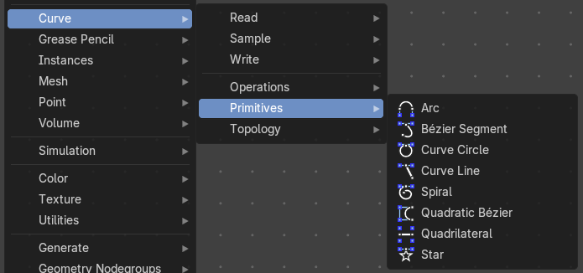
Add curve primitives in different shapes.

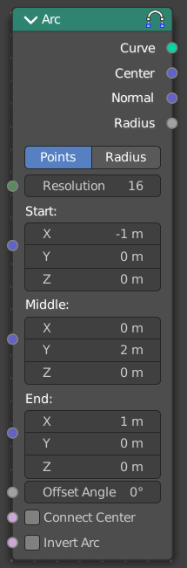
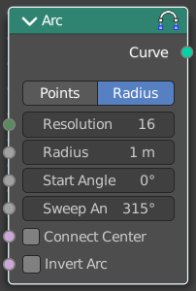
Arc
Adds a bezier curve segment in the shape of an arc

Inputs

Resolution
The number of edges on the curve.

in Radius mode

Radius
Just Radius mode. The radius of the arc.

Start Angle
Just Radius mode. The start angle of the arc.

Sweep Angle
Just Radius mode. The sweep angle of the arc.

In Points Mode

Start
The start point vector of the ark.

Middle
The middle point vector of the ark.

End
The end point vector of the ark.

Offset Angle
The offset angle of the ark.

Connect Center
Connect the start and endpoins to the center.

Invert Arc
Inverts the arc.

Properties

Mode
Point or Radius mode.
Radius mode (default): Generates a fixed radius arc on XY plane with controls for Angle, Sweep and Invert.
Points mode: Generates a three point curve arc from Start to End via Middle with an Angle Offset and option to invert the arc. There are also outputs for arc center, radius and normal direction relative to the Z-axis.

Outputs

Curve
Curve output.

In Points Mode

Center
The center vector of the arc.

Normal
The normal of the arc.

Radius
The radius of the arc.

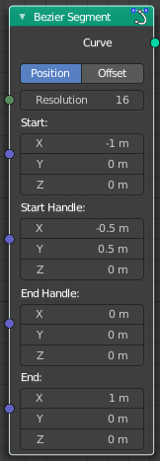
Bezier Segment
Adds a bezier curve segment.

Inputs

Resolution
The number of edges on the curve.

Start, End
Positions of the start and end control point of the curve.

Start Handle, End Handle
Positions of the handles used to define the shape of the curve.

Properties

Mode

Position
The handle inputs are the absolute positions of the handles in 3D space.

Offset
The handle positions are relative to the control point on the curve. The handle inputs give the offset from the control points.

Outputs

Curve
Bezier spline generated from the inputs.

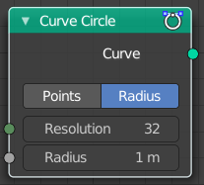
Curve Circle
Adds a curve in circle shape.

Inputs

Resolution
Number of edges on the circle.

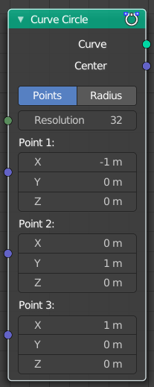
Radius
The radius of the circle.

Point 1, Point 2, Point 3
Appears when you change the method to Points. Defines three points on the circle. The order of the points determines the direction (clockwise or counterclockwise) of the circle.
Note that because of the finite resolution, the three points do not necessarily lie on the generated curve.

Properties

Mode

Points
The position and radius of the circle is defined by three points. The center of the circle is also given as an output. If the three points lie on one line, no geometry is generated.

Radius
The circle is defined by the radius.

Outputs

Curve
Poly spline generated from the inputs.

Center
Appears when you change the method to Points. The center of the circle defined by the three points.

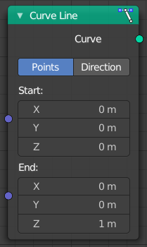
Curve Line
Adds a curve in the shape of a straight line.

Properties

Points
Calculates the curve by a start and end point.

Start
The start point of the curve.

End
The end point of the curve.

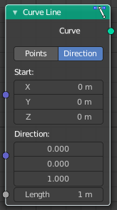
Direction
Calculates the curve by a start point, a direction vector and the length of the curve.

Start
The start point of the curve.

Direction
The direction vector.

Length
The length of the curve.

Outputs

Curve
The created curve.

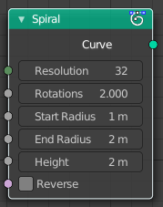
Spiral
Adds a curve in spiral shape. By default the spiral twists clockwise.

Inputs

Resolution
Number of edges for each full rotation.

Rotations
Number of times the spiral makes a full rotation.

Start Radius, End Radius
Radius of the start point and end point of the spiral. The radius of the spiral changes linearly between the two values over the whole spiral.

Height
Height of the spiral.

Reverse
Boolean value that changes the direction from clockwise to counterclockwise when turned on.

Outputs

Curve
Poly spline generated from the inputs.

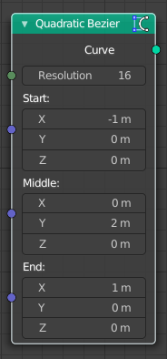
Quadratic Bezier
Adds a curve from the given control points. The generated shape is a parabola.

Inputs

Resolution
The number of edges on the curve.

Start, Middle, End
Positions of the three control points. The generated curve passes through the two end points, and is tangent to the lines between the middle point and the two end points.

Outputs

Curve
Poly spline generated from the inputs.

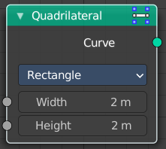
Quadrilateral
Adds a curve in different geometric shapes.
Note that the names does not necessarily fit to the generated geometry.

Input
The input nodes may vary. See Properties.

Properties

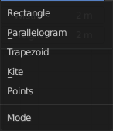
Mode

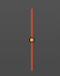
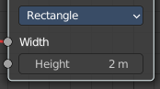
Rectangle
creates a straight line in y direction.

Width
The length of the straight line.

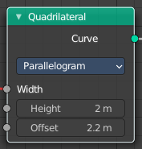
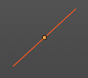
Parallelogram
Creates a straight line that is adjustable in x and y direction.

Height
The height of the line.

Offset
The width of the line.

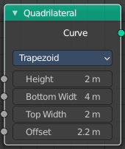
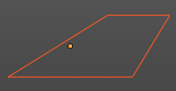
Trapezoid

Height
The height of the trapez.

Bottom Width
The width of the bottom line of the trapez.

Top Width
The width of the top line of the trapez.

Offset
The offset of the top line of the trapez.

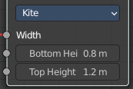
Kite
creates a straight line in y direction. The curve end points are separately adjustable

Bottom Height
The length of the bottom part of the line.

Top Height
The length of the top part of the line.

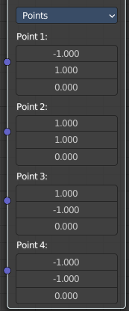
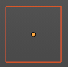
Points
Creates a rectangle. Each point of the rectangle is independantly adjustable in x, y and z position.

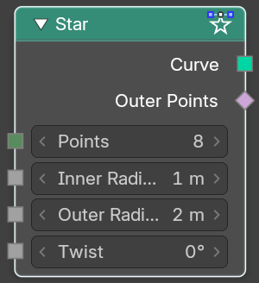
Star
Adds a curve in star shape.
This is done by connecting alternating points of two circles. The points on the inner circle are offset by a rotation so that they lie in between the points on the outer circle. This offset can be changed with the twist input.

Inputs

Points
Number of points on each of the circles.

Inner Radius, Outer Radius
Radii of the two circles. The inner radius can be bigger than the outer radius.

Twist
Angle offset of the inner circle. The twist value rotates the points on the circle corresponding with the inner radius counterclockwise by the given angle.

Outputs

Curve
Poly spline generated from the inputs.

